

SOFTWARE DESIGN SPECIFICATION
Japanese Skill Practice Platform

– Hanoi, July 2026 –

Table of Contents
I. Record of Changes 3
II. Software Design Document 4
1. High Level Design 4
1.1 Software Architecture 4
1.2 Package Diagram 4
1.3 Database Design 7
2. State Transition Diagrams 15
2.1 Test Attempt Status 15
2.2 Student Submission Status 15
2.3 Learning Content Review Status 15
3. Detailed Design 17
3.1 Authentication & Login 17
3.2 Quiz Submission (Assessment) 19
3.3 Flashcard SRS (Spaced Repetition) 21
3.4 Kanji Writing Evaluation (OCR/DTW Similarity) 23
3.5 Speaking Submission Grading (Shadowing) 25
3.6 Content Review (Manager Approve/Reject) 27

I. Record of Changes
Date | A*  M, D | In charge | Change Description
*A - Added M - Modified D - Deleted

II. Software Design Document

1. High Level Design

1.1 Software Architecture
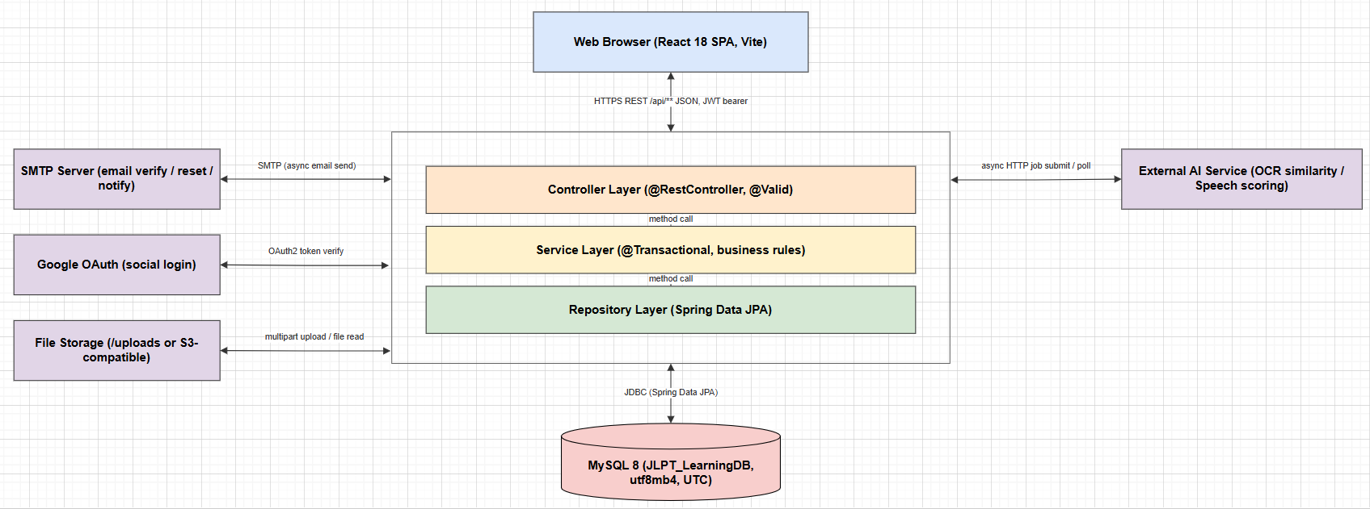

1.2 Package Diagram

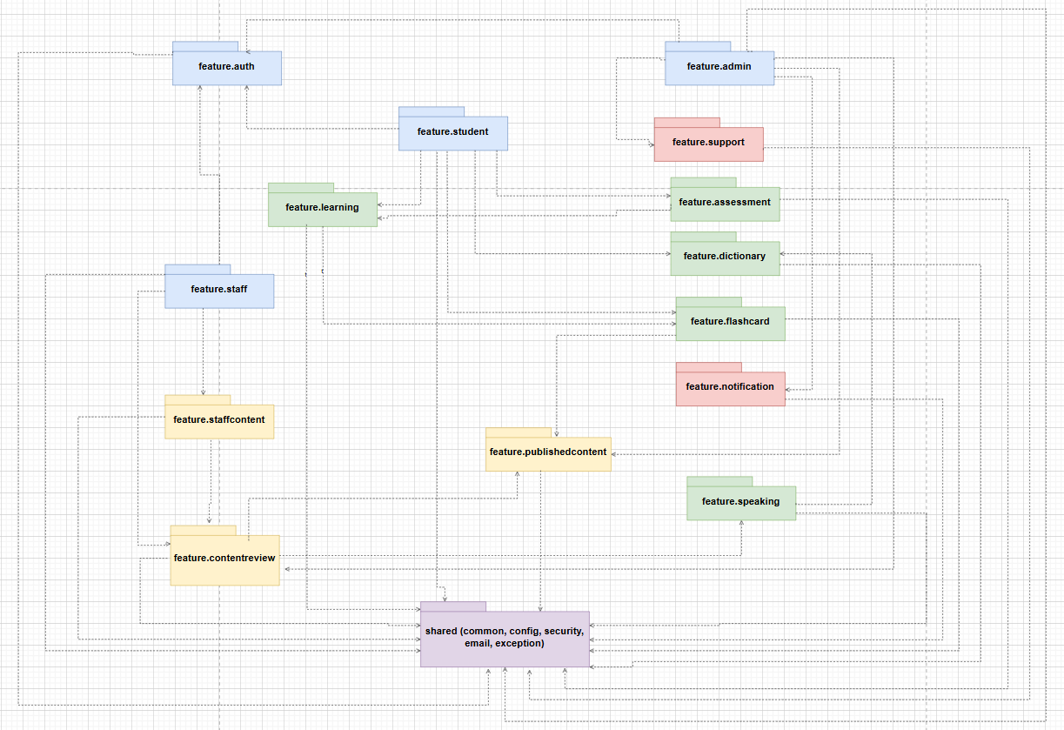
Package descriptions
No | Package | Description
01 | auth | Student login/register, JWT access + refresh token, email verification, forgot password, Google OAuth login.
02 | staff | Staff/StaffManager accounts: separate login, staff member management, staff password reset.
03 | admin | Admin accounts, audit log, statistics dashboard, system configuration (system_settings), maintenance mode.
04 | student | Student profile, dashboard, learning progress (student_content_progress), avatar, enrolled courses.
05 | learning | Learning content: Kana, Kanji, Vocabulary, Grammar, Lesson by JLPT level (N5-N1).
06 | assessment | Question bank, Quiz/Exam (Assessment), attempts (TestAttempt), server-side grading, speaking/writing submissions (StudentSubmission).
07 | speaking | Student records and submits speaking (shadowing) exercises, polls the result (SpeakingController/SpeakingService); grading is done by teachers in the support package — no AI auto-grading step (removed by a recent refactor).
08 | staffcontent | Where Staff draft content before publishing: questions, quizzes, exams, grammar, vocabulary, and a dedicated Staff dashboard.
09 | contentreview | Content review flow for Staff-authored content (approve/reject) before it goes public, with review audit logging.
10 | publishedcontent | Snapshot of published content, served to Students (kept separate from Staff's draft copy).
11 | flashcard | Flashcard + Spaced Repetition (SRS), system decks or user-created decks.
12 | dictionary | Kanji/Vocabulary dictionary lookup by keyword or type.
13 | notification | Notifications sent to individual Students (notification type, delivery channel).
14 | support | Support tickets submitted by Students and staff replies (TicketReply); Staff's speaking-grading queue (SupportTicketService, UC-31).

1.3 Database Design
[Provide the files description, database table relationship & table descriptions like example below]

1.3.1 admin_users
System administrator accounts.

No | Field | PK | FK | UN | NN | Description
01 | admin_id | X |  |  | X | PK, auto-increment.
02 | email |  |  | X | X | Login email, unique.
03 | password_hash |  |  |  |  | Bcrypt hash (cost >= 10, ADR-003); nullable until first password set.
04 | full_name |  |  |  | X | Display name.
05 | status |  |  |  | X | active / suspended / pending / deleted.
06 | login_attempts |  |  |  | X | Failed login counter for lockout.
07 | locked_until |  |  |  |  | Lockout expiry timestamp.
08 | last_login_at |  |  |  |  | Last successful login.
09 | created_at / updated_at |  |  |  | X | Audit timestamps.

1.3.2 staff_users
Staff and StaffManager accounts (StaffManager is staff_role='staff_manager', not a separate table).
No | Field | PK | FK | UN | NN | Description
01 | staff_id | X |  |  | X | PK, auto-increment.
02 | email |  |  | X | X | Login email, unique.
03 | password_hash |  |  |  |  | Bcrypt hash; nullable until Admin provisions/first login.
04 | full_name |  |  |  | X | Display name.
05 | staff_role |  |  |  | X | staff / staff_manager.
06 | status |  |  |  | X | active / suspended / pending / deleted.
07 | must_change_password |  |  |  | X | Forces password change after Admin-issued temp password.
08 | login_attempts / locked_until / last_login_at |  |  |  |  | Lockout tracking, same pattern as admin_users.
09 | created_at / updated_at |  |  |  | X | Audit timestamps.

1.3.3 student_users
Student accounts, including Google OAuth identity and JLPT level/streak tracking.
No | Field | PK | FK | UN | NN | Description
01 | staff_id | X |  |  | X | PK, auto-increment.
02 | email |  |  | X | X | Login email, unique.
03 | password_hash |  |  |  |  | Bcrypt hash; nullable until Admin provisions/first login.
04 | full_name |  |  |  | X | Display name.
05 | staff_role |  |  |  | X | staff / staff_manager.
06 | status |  |  |  | X | active / suspended / pending / deleted.
07 | must_change_password |  |  |  | X | Forces password change after Admin-issued temp password.
08 | login_attempts / locked_until / last_login_at |  |  |  |  | Lockout tracking, same pattern as admin_users.
09 | created_at / updated_at |  |  |  | X | Audit timestamps.

1.3.4 auth_tokens
Shared token store (session, refresh, reset password, email verification) for all 3 actor types
No | Field | PK | FK | UN | NN | Description
01 | token_id | X |  |  | X | PK, auto-increment.
02 | actor_type |  |  |  | X | admin / staff / student.
03 | admin_id / staff_id / student_id |  | X |  |  | Exactly one is set, per actor_type (CK_auth_token_actor).
04 | token_type |  |  |  | X | session / email_verification / password_reset / refresh / limited_session.
05 | token_value |  |  |  | X | Random UUID, or 6-digit OTP for email_verification.
06 | ip_address |  |  |  |  | Request IP at issuance.
07 | expires_at |  |  |  | X | Expiry timestamp.
08 | revoked_at |  |  |  |  | Soft revoke on logout (ADR-004 — no hard delete).
09 | created_at |  |  |  | X | Issue timestamp.

1.3.5 questions
Question bank with inline A/B/C/D options (no separate question_options table).
No | Field | PK | FK | UN | NN | Description
01 | question_id | X |  |  | X | PK, auto-increment.
02 | question_text |  |  |  | X | Question body.
03 | question_type |  |  |  | X | multiple_choice / fill_blank / true_false.
04 | skill |  |  |  | X | vocabulary / grammar / kanji / reading / listening / mixed.
05 | jlpt_level |  |  |  | X | N5-N1.
06 | option_a .. option_d / correct_option |  |  |  |  | Inline options + correct letter (multiple_choice).
07 | correct_answer_text |  |  |  |  | Correct text (fill_blank).
08 | created_by / approved_by |  | X |  |  | FK -> staff_users.
09 | status |  |  |  | X | draft / pending_review / rejected / published / archived / deleted.
10 | published_at / created_at / updated_at |  |  |  |  | Lifecycle timestamps.

1.3.6 assessments
Quiz and Exam combined via assessment_type (no separate quizzes/exams tables).
No | Field | PK | FK | UN | NN | Description
01 | assessment_id | X |  |  | X | PK, auto-increment.
02 | assessment_type |  |  |  | X | quiz / exam.
03 | title |  |  |  | X | Assessment title.
04 | lesson_id |  | X |  |  | FK -> lessons, optional link to a lesson.
05 | jlpt_level / duration_min / pass_score / total_score |  |  |  |  | Exam parameters.
06 | status |  |  |  | X | draft / pending_review / rejected / published / archived / deleted.
07 | is_deleted |  |  |  | X | Soft delete flag (ADR-004).
08 | created_by / approved_by |  | X |  |  | FK -> staff_users.
09 | published_at / created_at / updated_at |  |  |  |  | Lifecycle timestamps.

1.3.7 test_attempts
One quiz/exam/practice attempt by a Student; status prevents double submission (LESSON-005).
No | Field | PK | FK | UN | NN | Description
01 | attempt_id | X |  |  | X | PK, auto-increment.
02 | student_id |  | X |  | X | FK -> student_users, ON DELETE CASCADE.
03 | attempt_type |  |  |  | X | exam / quiz / practice / reading / listening.
04 | parent_type / parent_id |  |  |  | X* | *parent_type required; identifies the assessment/lesson attempted.
05 | started_at / submitted_at / duration_seconds |  |  |  |  | Timing, validated server-side (BR-02).
06 | total_score / max_score / is_passed |  |  |  |  | Computed only in the Service layer, never trusted from client (BR-02).
07 | language_knowledge_score / reading_score / listening_score |  |  |  |  | Per-section JLPT scores.
08 | status |  |  |  | X | in_progress / submitted / auto_submitted / abandoned (see §2.1 State Diagram).

1.3.8 attempt_answers
A Student's answer to each question in an attempt, used for grading and review.
No | Field | PK | FK | UN | NN | Description
01 | answer_id | X |  |  | X | PK, auto-increment.
02 | attempt_id |  | X |  | X | FK -> test_attempts, ON DELETE CASCADE.
03 | question_id |  | X |  | X | FK -> questions.
04 | selected_option / answer_text |  |  |  |  | Student's answer (multiple_choice / fill_blank).
05 | is_correct / score |  |  |  |  | Computed server-side during grading (BR-02).
06 | answered_at |  |  |  | X | Answer timestamp.

1.3.9 student_submissions
Speaking/handwriting submissions requiring Staff grading (legacy AI columns kept for old data).
No | Field | PK | FK | UN | NN | Description
01 | submission_id | X |  |  | X | PK, auto-increment.
02 | student_id |  | X |  | X | FK -> student_users, ON DELETE CASCADE.
03 | submission_type |  |  |  | X | speaking / handwriting.
04 | status |  |  |  | X | pending / ai_graded / graded / rejected (see §2.2 State Diagram).
05 | exercise_id |  | X |  |  | FK -> lessons (speaking exercise).
06 | recording_url / duration_seconds |  |  |  |  | Speaking submission media (no BLOB, ADR-006).
07 | ai_overall_score .. ai_graded_at |  |  |  |  | Legacy AI-grading columns; not written by current code.
08 | kanji_id / kana_id |  | X |  |  | FK -> kanji / kana_characters (handwriting OCR target).
09 | handwriting_image_url / expected_character / recognized_character / similarity_percent |  |  |  |  | OCR handwriting fields (ADR-007: similarity % only).
10 | manual_score / manual_feedback / graded_by / graded_at |  | X* |  |  | *graded_by -> staff_users. Staff's final grade (AGENTS.md §7.5).
11 | submitted_at / updated_at |  |  |  | X | Lifecycle timestamps.

1.3.10 flashcard_decks
Flashcard deck (system or personal); first-class table separate from flashcards.
No | Field | PK | FK | UN | NN | Description
01 | deck_id | X |  |  | X | PK, auto-increment.
02 | student_id |  | X |  |  | FK -> student_users; NULL for system decks.
03 | name / description / jlpt_level / topic / color / display_order |  |  |  |  | Deck metadata.
04 | is_system / is_review_deck |  |  |  | X | System deck flag; 1 auto-generated review deck per student.
05 | is_deleted |  |  |  | X | Soft delete flag (ADR-004).
06 | active_name_key / review_deck_key |  |  | X |  | Generated columns emulating SQL Server's filtered unique index on MySQL.

1.3.11 flashcards
One flashcard belonging to a Student, plus SRS state (ease_factor, interval_days, next_review_date).
No | Field | PK | FK | UN | NN | Description
01 | flashcard_id | X |  |  | X | PK, auto-increment.
02 | student_id |  | X |  |  | FK -> student_users.
03 | deck_id |  | X |  | X | FK -> flashcard_decks.
04 | content_type / content_id |  |  |  | X* | *content_type required; kanji / vocabulary / grammar / custom.
05 | front_text / back_text |  |  |  |  | Card content (custom cards).
06 | last_rating |  |  |  |  | easy / hard / wrong — last SM-2 review outcome.
07 | interval_days / repetition_count / ease_factor / next_review_date / last_reviewed_at |  |  |  |  | SM-2 spaced-repetition state (default ease_factor 2.50).
08 | last_session_id |  |  |  |  | Groups cards reviewed in the same session.
09 | is_deleted / created_at |  |  |  | X | Soft delete flag + creation timestamp.

1.3.12 kanji_writing_attempts
One Student attempt at hand-writing a Kanji character on canvas; DTW similarity score.
No | Field | PK | FK | UN | NN | Description
01 | attempt_id | X |  |  | X | PK, auto-increment.
02 | student_id |  | X |  | X | FK -> student_users.
03 | kanji_id / character_value |  |  |  | X* | *character_value required; kanji_id references kanji.kanji_id.
04 | total_strokes / avg_dtw_score |  |  |  | X* | *total_strokes required; avg_dtw_score is the DTW similarity metric (ADR-007).
05 | final_quality |  |  |  |  | perfect / good / ok / bad, derived from avg_dtw_score thresholds.
06 | stroke_details |  |  |  |  | Per-stroke coordinates (JSON text).
07 | is_deleted / created_at / updated_at / created_by |  |  |  | X* | *is_deleted required; soft delete flag (ADR-004).

1.3.13 admin_audit_logs
Records every content-review / submission-grading / admin action taken by Staff, StaffManager, or Admin.
No | Field | PK | FK | UN | NN | Description
01 | audit_id | X |  |  | X | PK, auto-increment.
02 | admin_actor_id / staff_actor_id / student_actor_id |  | X |  |  | Exactly one is set (CK_audit_actor).
03 | action |  |  |  | X | Action name, e.g. APPROVE_CONTENT, GRADE_SUBMISSION.
04 | target_table / target_id |  |  |  |  | The row the action was performed on.
05 | description |  |  |  |  | Free-text detail of the action.
06 | ip_address / created_at |  |  |  | X* | *created_at required; actor's IP + audit timestamp.

2. State Transition Diagrams

2.1 Test Attempt Status
Status column: test_attempts.status. Applies to every quiz/exam/practice attempt (UC-10, UC-11). The attempt starts in_progress on the server, and moves to exactly one final state — submitted (student action), auto_submitted (server-side timer), or abandoned (session ends without submitting). All three final states are immutable once reached (BR-04): the score and answers can never be changed afterward.
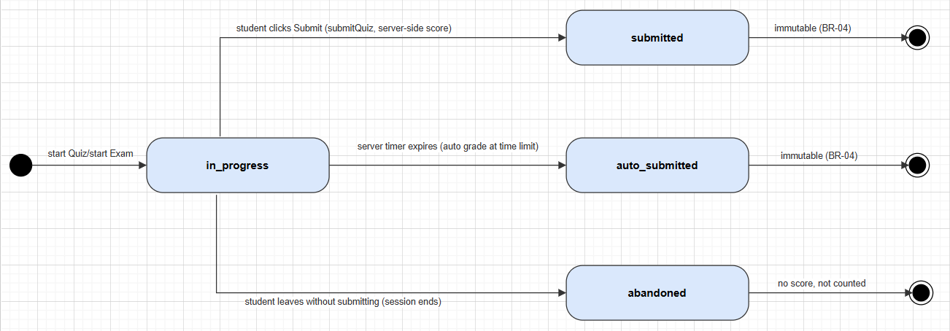

2.2 Student Submission Status
Status column: student_submissions.status. Applies to speaking (UC-13) and handwriting (UC-20) submissions. The current code path is pending -> graded / rejected by Staff (SupportTicketService.manualGrade); the ai_graded state and its transitions (dashed, red) are legacy — the schema still allows them for old data, but no current code path creates them, since AI auto-grading was removed (commit db0d1648).
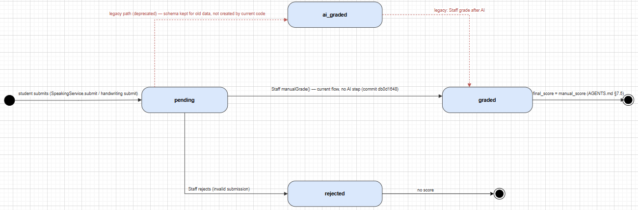

2.3 Learning Content Review Status
Shared status column used by lessons, kanji, vocabulary, grammar_points, questions, and assessments. Staff authors content as draft, submits it for pending_review, and a StaffManager either approves (published), rejects, or requests changes (back to draft) — see ContentReviewService in §3.6. Published content can later be archived/restored, and archived content can be soft-deleted (ADR-004: is_deleted flag or status=deleted, never a hard DELETE).
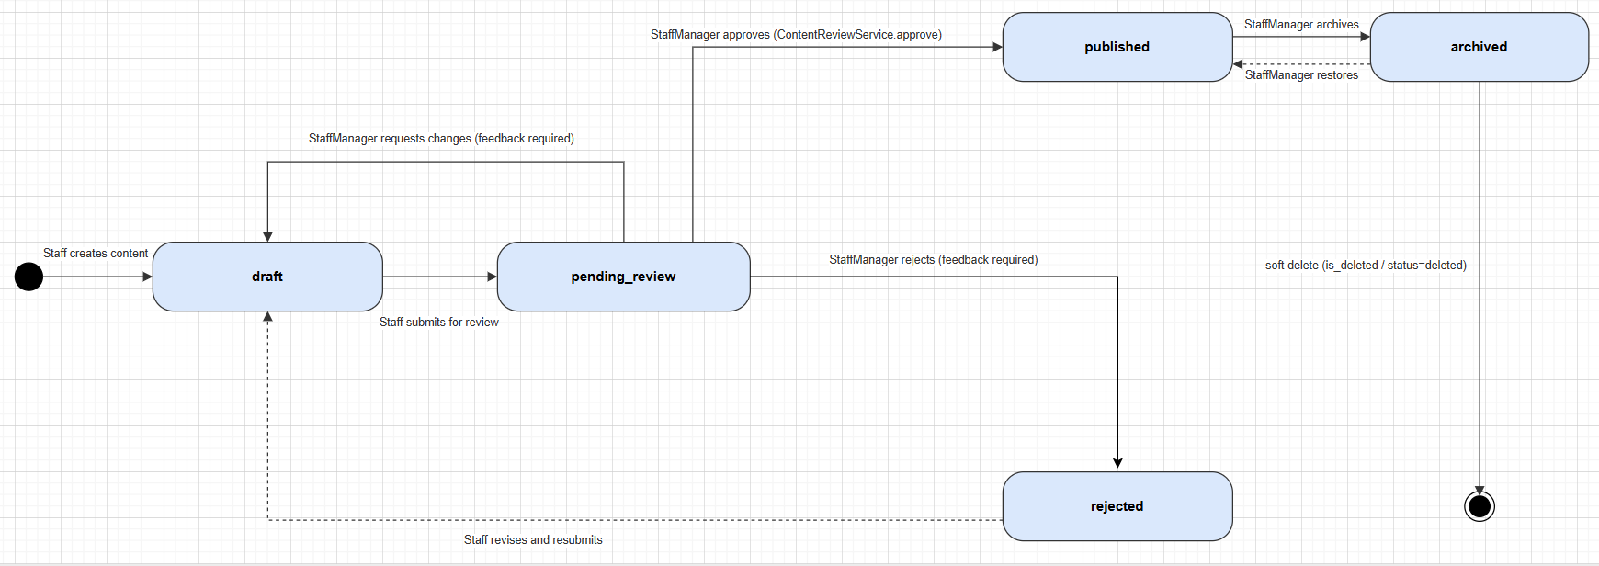

3. Detailed Design

3.1 Authentication & Login

3.1.1 Class Diagram
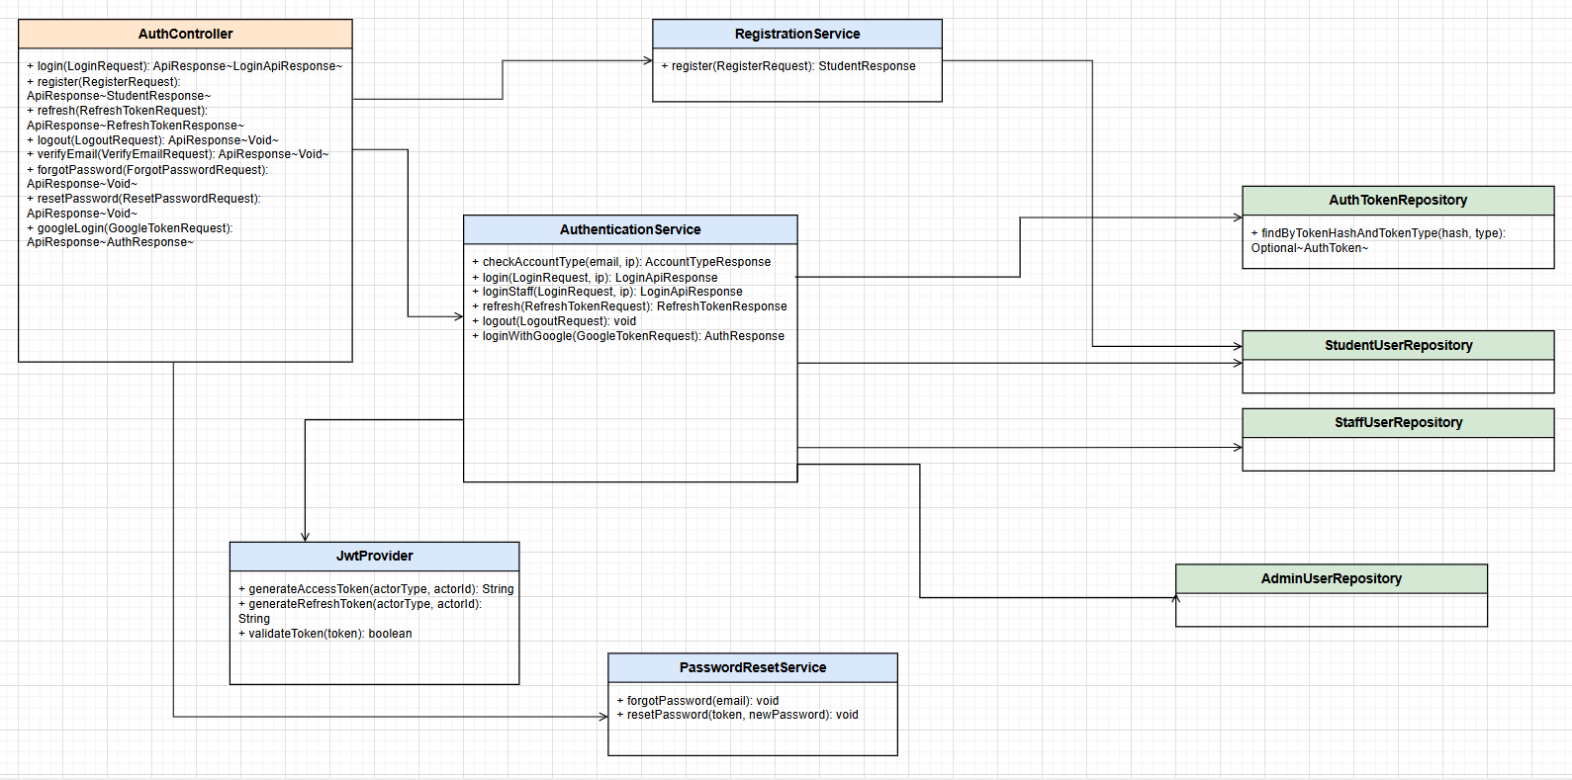
Class Specifications
AuthenticationService Class
No | Method | Description
01 | checkAccountType(email, ip) | Input: email, caller IP. Rate-limited to 10 calls/minute/IP. Returns the account type (Student/Staff/Admin) or not-found so the FE can show the right login form.
02 | login(LoginRequest, ip) | Authenticates a Student via AuthenticationManager + passwordEncoder; on success, issues an access token + refresh token (JwtProvider) and stores the refresh token in auth_tokens with actor_type=STUDENT.
03 | loginStaff(LoginRequest, ip) | Same as login but for StaffUser/AdminUser; additionally checks the account status (locked/inactive).
04 | refresh(RefreshTokenRequest) | Input: refresh token. Looks up auth_tokens by hash, checks expires_at and that it has not been revoked, issues a new access token (rotating the refresh token).
05 | logout(LogoutRequest) | Revokes (marks) the current refresh token in auth_tokens — no hard-delete (ADR-004).
06 | loginWithGoogle(GoogleTokenRequest) | Verifies the Google ID token, finds or creates a student_users row by oauth_provider_id, issues a JWT the same way as a normal login.
RegistrationService Class
No | Method | Description
01 | register(RegisterRequest) | Input: email, password, name. Hashes the password with bcrypt cost >= 10 (ADR-003), creates student_users with email_verified_at=null, and publishes a SendVerificationEmailEvent asynchronously.

3.1.2 User Login Sequence
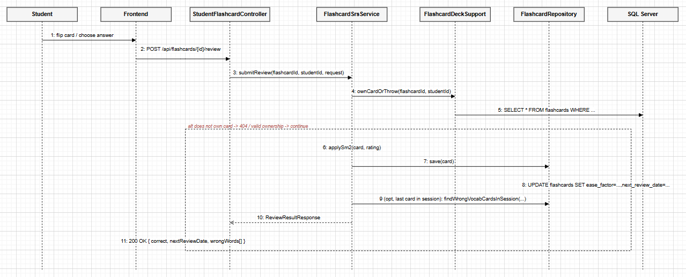
Database Queries
-- checkAccountType / login: look up the account by email
SELECT * FROM student_users WHERE email = ? AND is_deleted = 0;
-- store the refresh token on successful login
INSERT INTO auth_tokens (actor_type, actor_id, token_type, token_hash, expires_at, created_at)
VALUES ('STUDENT', ?, 'REFRESH', ?, ?, GETDATE());
-- refresh(): look up a still-valid refresh token
SELECT * FROM auth_tokens
WHERE token_hash = ? AND token_type = 'REFRESH' AND expires_at > GETDATE();
-- logout(): revoke the token (soft, no DELETE)
UPDATE auth_tokens SET revoked_at = GETDATE() WHERE token_hash = ?;

3.2 Quiz Submission (Assessment)

3.2.1 Class Diagram
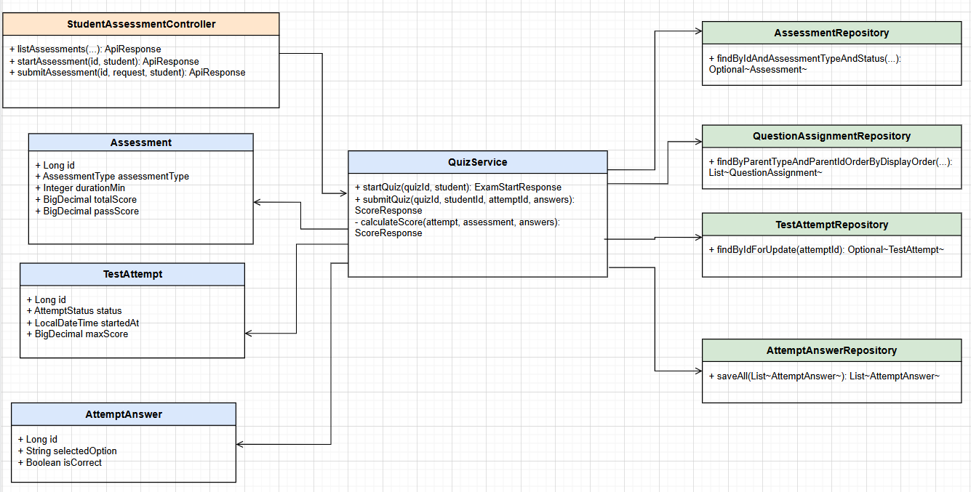
Class Specifications
QuizService Class
No | Method | Description
01 | startQuiz(quizId, student) | Input: quiz id, the current Student. Checks the quiz is PUBLISHED, loads the assigned questions (question_assignments), creates a new TestAttempt with status=IN_PROGRESS. Never returns the correct answers to the client.
02 | submitQuiz(quizId, studentId, attemptId, answers) | Locks the test_attempts row with findByIdForUpdate (pessimistic lock) to prevent a race on duplicate submission; checks attempt.student.id==studentId (blocks submitting on someone else's behalf) and status==IN_PROGRESS (blocks double submission, LESSON-005). Calls calculateScore.
03 | calculateScore(attempt, assessment, answers) | The score is computed entirely server-side, never trusting a score from the client: matches answers against each Question's correct_option, saves each AttemptAnswer, updates attempt.status=SUBMITTED.

3.2.2 Submit Quiz Sequence
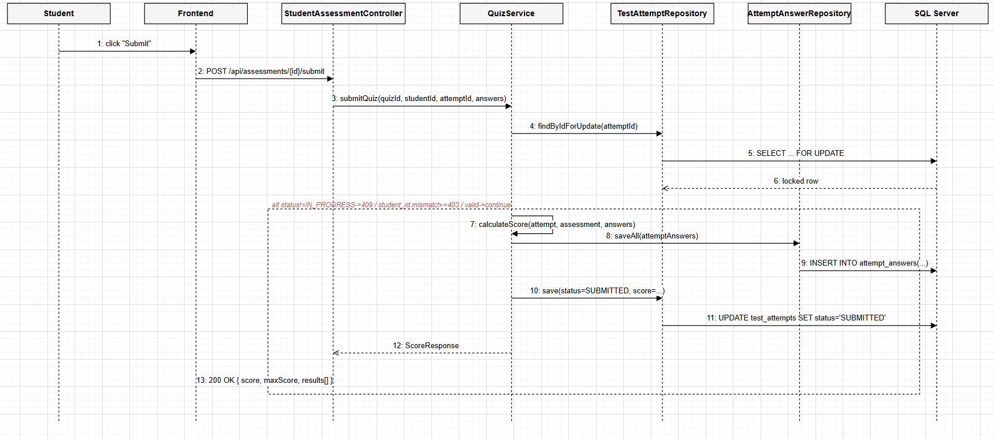
Database Queries
-- startQuiz(): check the quiz is published
SELECT * FROM assessments
WHERE id = ? AND assessment_type = 'QUIZ' AND status = 'PUBLISHED';
-- load the assigned questions, in display order
SELECT qa.* FROM question_assignments qa
WHERE qa.parent_type = 'ASSESSMENT' AND qa.parent_id = ?
ORDER BY qa.display_order;
-- create a new attempt when the student starts the quiz
INSERT INTO test_attempts (student_id, attempt_type, parent_type, parent_id, started_at, max_score, status)
VALUES (?, 'QUIZ', 'ASSESSMENT', ?, GETDATE(), ?, 'IN_PROGRESS');
-- submitQuiz(): lock the attempt row to prevent duplicate submission
SELECT * FROM test_attempts WITH (UPDLOCK, ROWLOCK) WHERE id = ?;
-- save each answer after grading
INSERT INTO attempt_answers (attempt_id, question_id, selected_option, is_correct)
VALUES (?, ?, ?, ?);
-- update the attempt after submission
UPDATE test_attempts
SET status = 'SUBMITTED', submitted_at = GETDATE(), score = ?
WHERE id = ?;

3.3 Flashcard SRS (Spaced Repetition)

3.3.1 Class Diagram
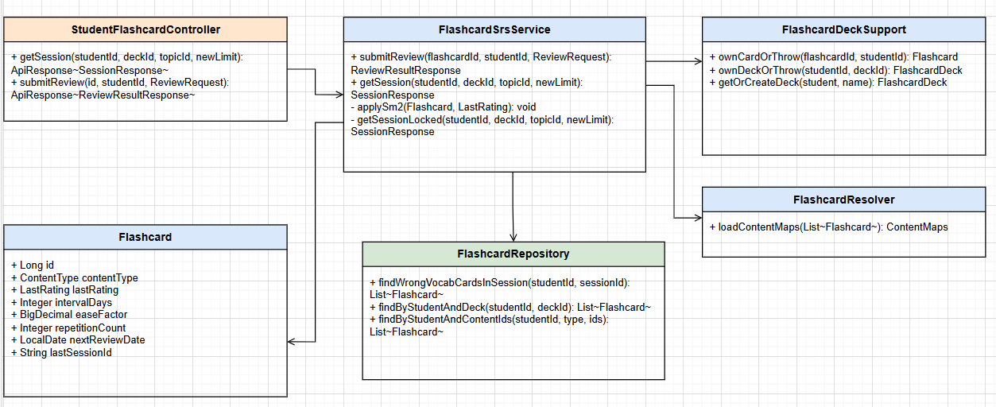
Class Specifications
FlashcardSrsService Class
No | Method | Description
01 | submitReview(flashcardId, studentId, ReviewRequest) | Verifies card ownership (ownCardOrThrow). For a multiple-choice vocabulary quiz, the server matches selectedOptionId against the correct contentId itself (never trusts a correct/incorrect flag from the client). Calls applySm2 to update the review schedule.
02 | getSession(studentId, deckId, topicId, newLimit) | Input: exactly one of deckId (personal notebook) or topicId (curriculum topic), plus a limit on new cards (default 10, cap 20). Locks on (studentId, deck/topic) to prevent two tabs creating a session at the same time. Priority order: not-yet-learned -> due for review -> the rest.
03 | applySm2(Flashcard, LastRating) | Implements the SM-2 algorithm: WRONG -> ease decreases (floor 1.30), repetitionCount resets; HARD -> ease unchanged; EASY -> ease+0.1 (cap 2.50). Always updates nextReviewDate = today + intervalDays.

3.3.2 Flashcard Review Sequence
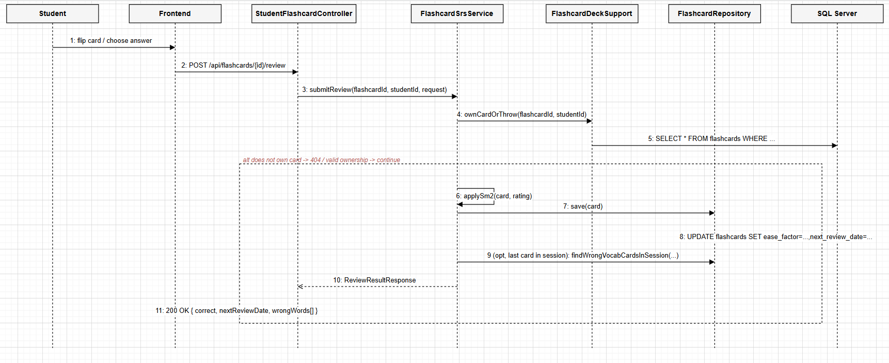
Database Queries
-- ownCardOrThrow(): verify card ownership before grading
SELECT * FROM flashcards
WHERE flashcard_id = ? AND student_id = ? AND is_deleted = 0;
-- applySm2() -> save(): update the review schedule after grading
UPDATE flashcards
SET ease_factor = ?, interval_days = ?, repetition_count = ?,
next_review_date = ?, last_reviewed_at = GETDATE(), last_rating = ?
WHERE flashcard_id = ?;
-- end of session: collect words answered wrong in THIS session
SELECT * FROM flashcards
WHERE student_id = ? AND last_session_id = ? AND content_type = 'VOCABULARY' AND last_rating = 'WRONG';

3.4 Kanji Writing Evaluation (OCR/DTW Similarity)

3.4.1 Class Diagram
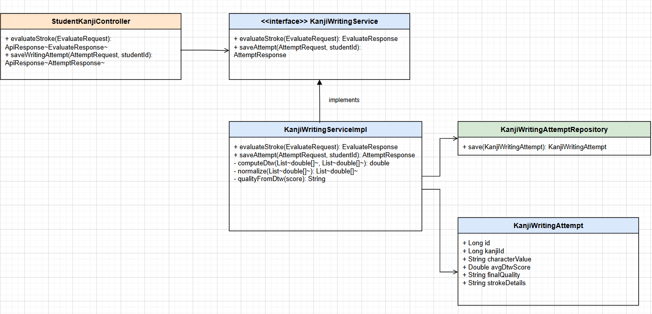
Class Specifications
KanjiWritingServiceImpl Class
No | Method | Description
01 | evaluateStroke(EvaluateRequest) | Input: the coordinates of the stroke the Student just drew + the reference stroke for that specific stroke index. Normalizes both paths (normalize+downsample to at most 20 points), computes the distance via DTW, maps it to a quality bucket using 3 fixed thresholds (300/650/1200). Synchronous, does not persist to the DB.
02 | saveAttempt(AttemptRequest, studentId) | Input: every stroke drawn for one Kanji character + the per-stroke DTW score. Computes avgDtwScore as the average of the per-stroke scores, derives finalQuality, saves one KanjiWritingAttempt row (with strokeDetails as JSON).
03 | computeDtw(s1, s2) | Classic Dynamic Time Warping (ADR-007: compares similarity % only, no stroke-order analysis like image-based OCR). Invariant to differences in drawing speed between the two paths.

3.4.2 Kanji Writing Evaluation Sequence
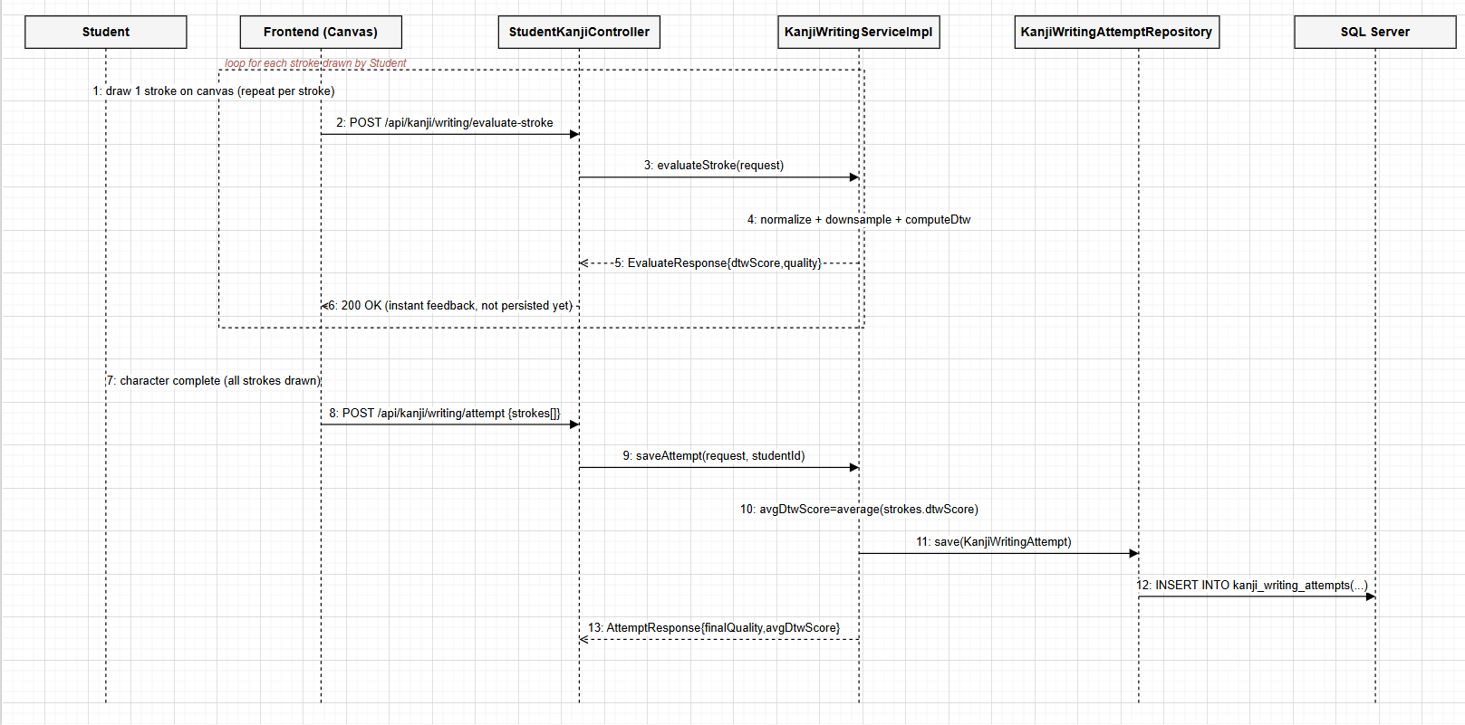
Database Queries
-- saveAttempt(): persist one completed writing attempt
INSERT INTO kanji_writing_attempts
(student_id, kanji_id, character_value, total_strokes, avg_dtw_score, final_quality, stroke_details, created_by)
VALUES (?, ?, ?, ?, ?, ?, ?, ?);
-- evaluateStroke() never queries the DB — all DTW computation happens in memory per request.

3.5 Speaking Submission Grading (Shadowing)

3.5.1 Class Diagram
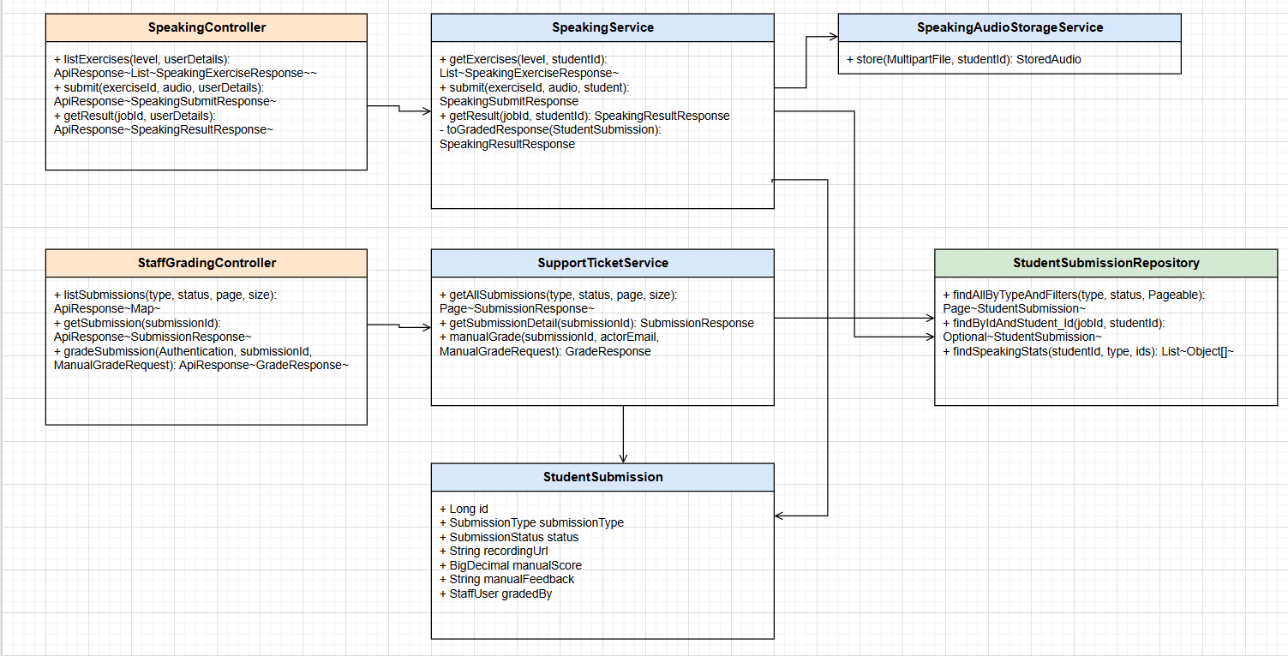
Class Specifications
SpeakingService Class
No | Method | Description
01 | getExercises(level, studentId) | Input: JLPT level + student id. Returns the list of published speaking exercises (Lesson of type SPEAKING) for that level, with attemptCount/bestScore (the student's highest teacher-graded score).
02 | submit(exerciseId, audio, student) | Input: exercise id + multipart audio file. Validates the exercise exists & is PUBLISHED, stores the file via SpeakingAudioStorageService (no BLOB in the DB, LESSON-002), creates a StudentSubmission with status=PENDING — there is no AI grading step (removed by a refactor, see the Sequence Diagram). Returns a jobId for the Student to poll.
03 | getResult(jobId, studentId) | Input: submission id + the calling student id (only ever returns that student's own submission). Returns PENDING if not yet graded (manualScore==null), COMPLETED with score/feedback once graded, FAILED if status=REJECTED.
SupportTicketService Class
No | Method | Description
01 | getAllSubmissions(submissionType, status, page, size) | Input: submissionType filter (default speaking), status, pagination. Returns a Page<SubmissionResponse> for the Staff grading queue (UC-31).
02 | getSubmissionDetail(submissionId) | Returns the detail of one submission: recordingUrl, and if already graded, manualScore/manualFeedback/gradedBy. finalScore = manualScore if present, otherwise falls back to aiOverallScore (a legacy column, always null for new data since the AI grading step was removed).
03 | manualGrade(submissionId, actorEmail, ManualGradeRequest) | Current business rule: can only grade a submission whose submissionType=SPEAKING (422 otherwise) and status != REJECTED (422 if already rejected) — no longer requires status=AI_GRADED as it used to, since the AI grading step was removed (commit db0d1648). Sets manualScore/manualFeedback/gradedBy/gradedAt, moves status to GRADED, sends a Notification (ACHIEVEMENT) and writes an AdminAuditLog.

3.5.2 Speaking Submission and Grading Sequence
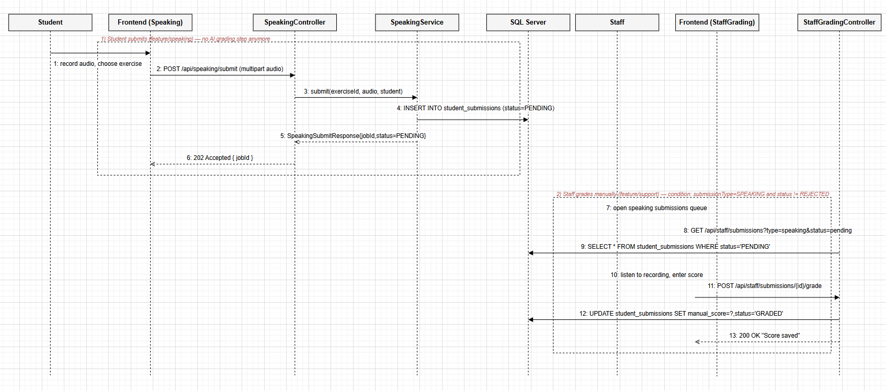
Database Queries
-- SpeakingService.submit(): create a new submission, awaiting teacher grading (no AI step anymore)
INSERT INTO student_submissions (student_id, submission_type, status, exercise_id, recording_url, created_at)
VALUES (?, 'SPEAKING', 'PENDING', ?, ?, GETDATE());
-- SupportTicketService.getAllSubmissions(): the speaking grading queue
SELECT * FROM student_submissions
WHERE submission_type = 'SPEAKING' AND (status = ? OR ? IS NULL)
ORDER BY submitted_at ASC;
-- manualGrade(): record the teacher's score, change status (no longer checks status=AI_GRADED)
UPDATE student_submissions
SET manual_score = ?, manual_feedback = ?, graded_by = ?, graded_at = GETDATE(), status = 'GRADED'
WHERE submission_id = ? AND status != 'REJECTED';
-- notify the Student once grading is done
INSERT INTO notifications (student_id, title, message, notification_type, reference_key, created_by)
VALUES (?, 'Your speaking submission has been graded', ?, 'ACHIEVEMENT', ?, ?);

3.6 Content Review (Manager Approve/Reject)

3.6.1 Class Diagram
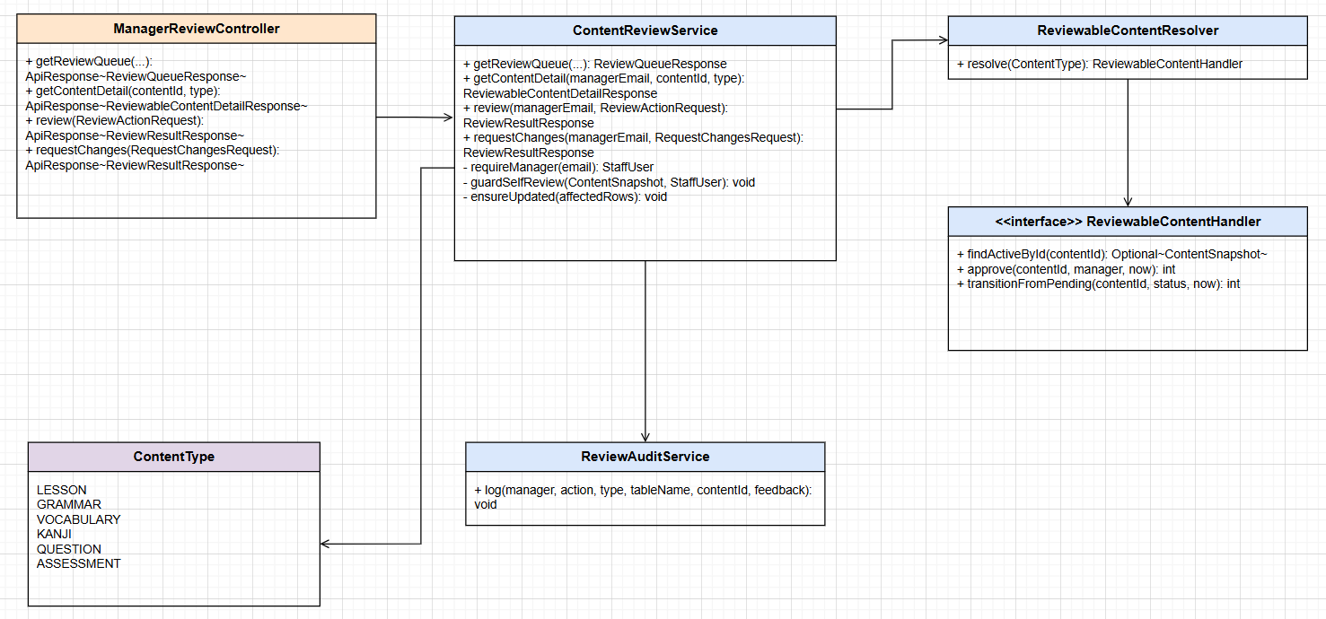
Class Specifications
ContentReviewService Class
No | Method | Description
01 | getContentDetail(managerEmail, contentId, typeStr) | Verifies managerEmail is an active STAFF_MANAGER (requireManager), resolves the right handler for the type (course/lesson/grammar/vocabulary/kanji/question/assessment), returns a snapshot (title, JLPT level, author, submission date, content).
02 | review(managerEmail, ReviewActionRequest) | Blocks reviewing one's own content (guardSelfReview). APPROVE -> handler.approve() (status=published); REJECT -> feedback is required, then handler.transitionFromPending(REJECTED). Every action is logged via ReviewAuditService.log(...).
03 | requestChanges(managerEmail, RequestChangesRequest) | Asks Staff to revise content: feedback is required, moves status back to draft (default) or rejected depending on targetStatus. Uses the same guardSelfReview + audit-log mechanism as review().
04 | ensureUpdated(affectedRows) | If the UPDATE affected 0 rows, the content is no longer in pending_review (already handled concurrently by another Manager) -> throws ConcurrentReviewException to prevent one review overwriting another.

3.6.2 Content Review Sequence
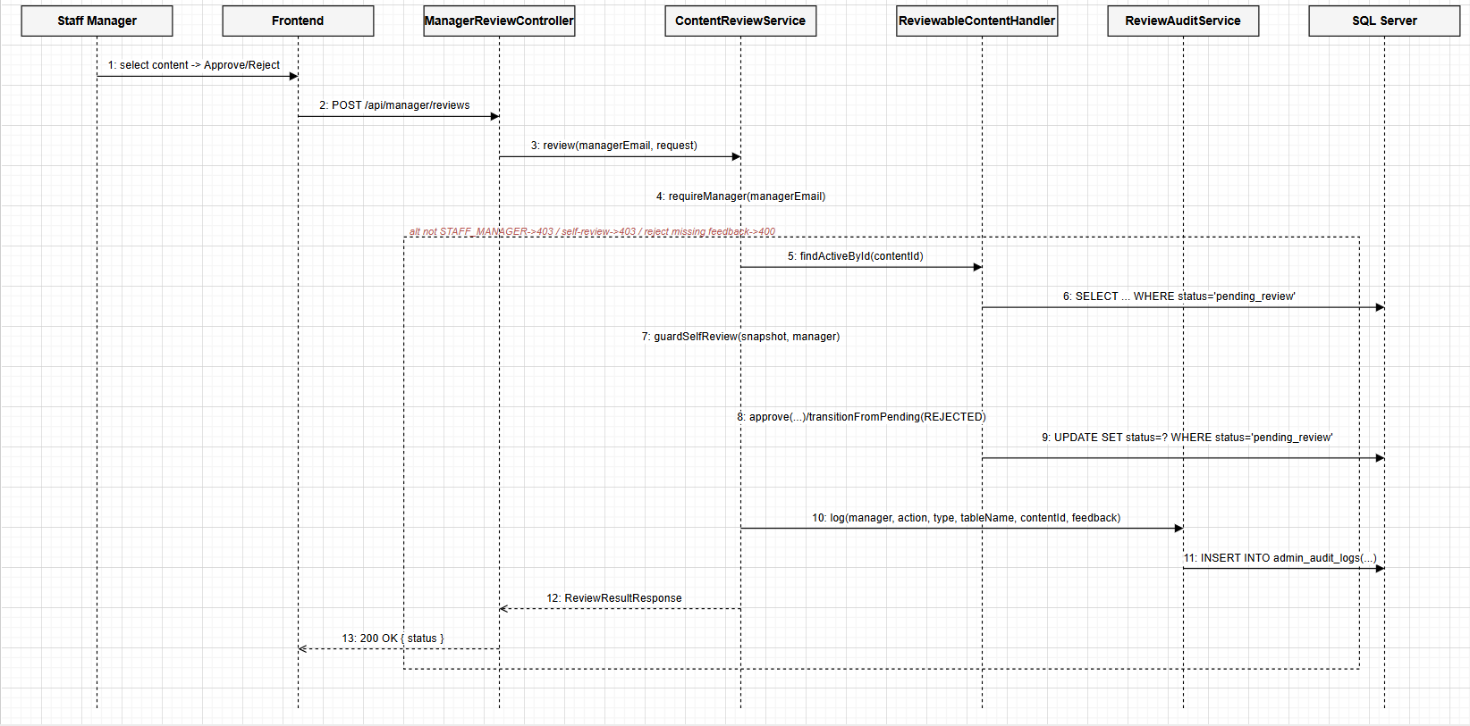
Database Queries
-- findActiveById(): fetch content awaiting review (example: the GRAMMAR handler)
SELECT * FROM grammar_points WHERE grammar_id = ? AND status = 'pending_review';
-- approve(): only updates if still pending_review (prevents double approval)
UPDATE grammar_points
SET status = 'published', approved_by = ?, published_at = GETDATE()
WHERE grammar_id = ? AND status = 'pending_review';
-- reject() / requestChanges(): move back to draft or rejected
UPDATE grammar_points
SET status = ?, updated_at = GETDATE()
WHERE grammar_id = ? AND status = 'pending_review';
-- write an audit row for every review action
INSERT INTO admin_audit_logs (staff_id, action, target_table, target_id, note, created_at)
VALUES (?, ?, ?, ?, ?, GETDATE());

